[Insert Name]
IT 327
Dr. Lunt
Homework #3
Supplemental, Chap 1: #12 (p. 12)

12. Find all the missing values for the circuit in Figure 1P-3. (75 pts)
Figure 1P-3: A 4-load parallel circuit.
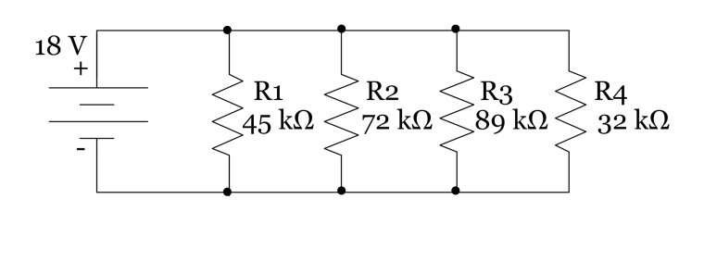

 | Voltage | Resistance | Current | Power
Total
R1
R2
R3
R4

